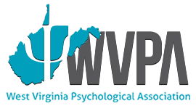
WV Psychological Association

Spring Training Event

“Trauma Informed Care & Seeking Safety”

DATE: Friday, April 27, 2018
9 a.m. – 4:30 p.m.

LOCATION: Marshall University
Memorial Student Center, Room BE5
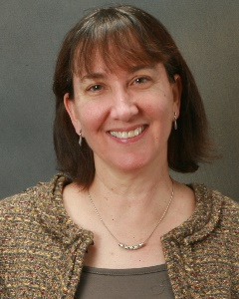
Huntington, WV

SPEAKER: Lisa Najavits, Ph.D.

Lisa Najavits, PhD, is professor of psychiatry at Boston University School of Medicine, adjunct professor at the University of Massachusetts Medical School, and a clinical research psychologist in the Veterans Affairs Healthcare System. Her clinical and research interests are substance abuse, trauma, co-morbidity, behavioral addictions, veterans' mental health, community-based care, development of new psychotherapies, and outcome research. She is author of over 190 professional publications, as well as the books Seeking Safety, A Woman's Addiction Workbook, and Recovery from Trauma, Addiction or Both: Finding Your Best Self. She has served as president of the Society of Addiction Psychology of the American Psychological Association, and was the recipient of the 2009 Betty Ford Award of the Addiction Medical Education and Research Association. She is a licensed psychologist and received her PhD in clinical psychology from Vanderbilt University.

REGISTRATION: https://www.treatment-innovations.org/store/p195/4-27-18-WV
This training is appropriate for all those who provide services to individuals with a history of trauma and substance related disorders including psychologists, counselors, addiction professionals, social workers, physicians, nurses, and peer recovery specialists

Co-sponsored by the Department of Psychology and The Wellness Center at Marshall University
For additional information please contact Penny Koontz, Psy.D. at koontz7@marshall.edu or Jocelyn Burum, Psy.D. at info@wvpsychology.org

